Wireframe Documentation
Telecom Churn Analytics
Business Intelligence

Homepage

- Telecom Analysis
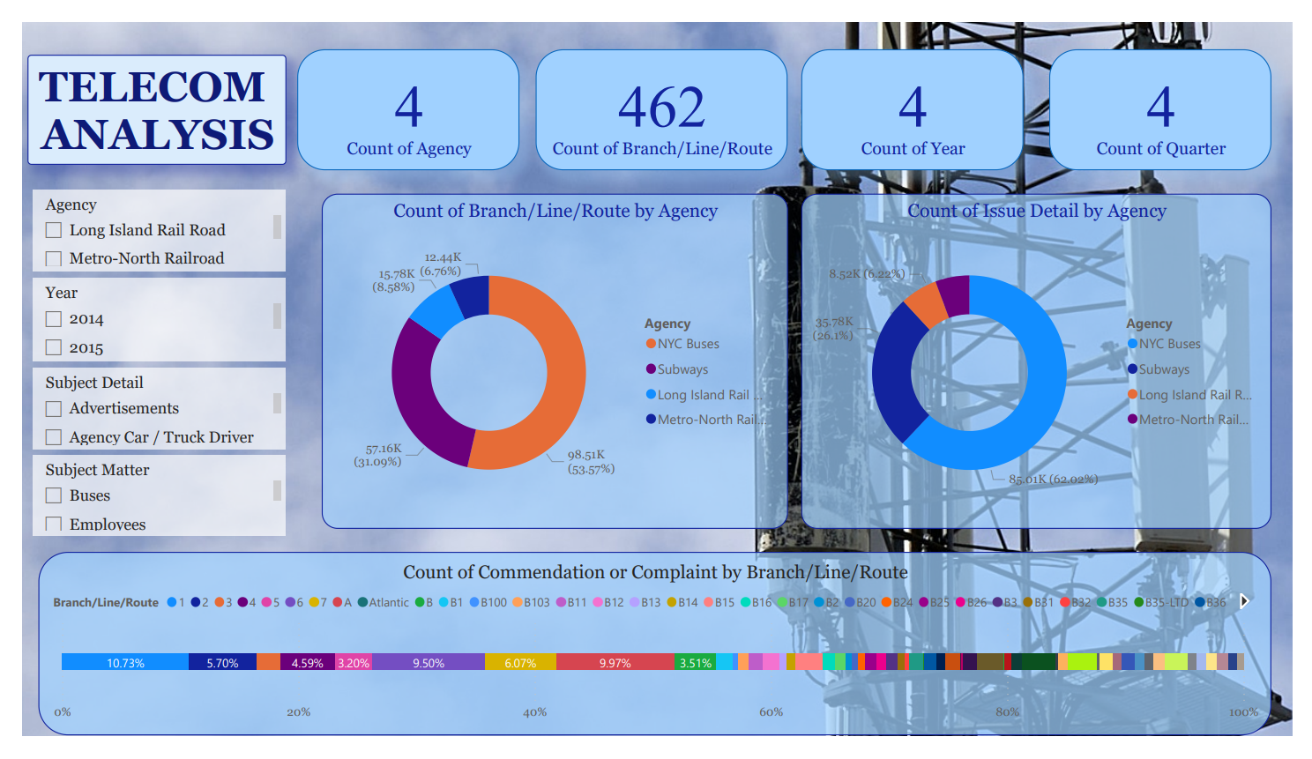

- Total No. of records and Agency, Branch, Year, Quarter

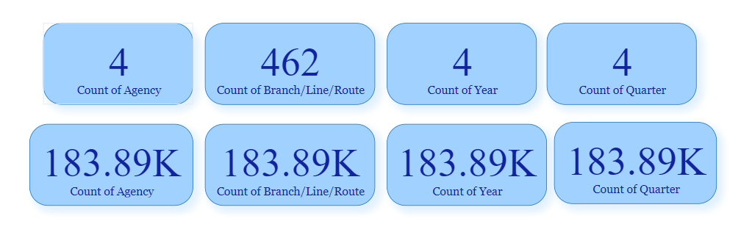

- Relation between Branch/ Line/ Route with agency
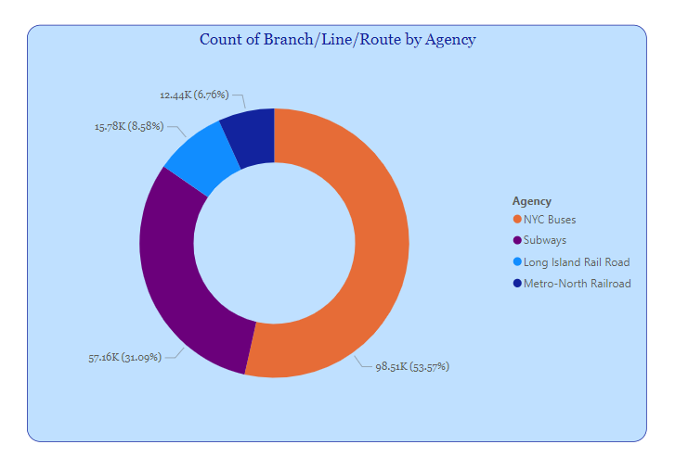
- Relation between Issue detail with agency

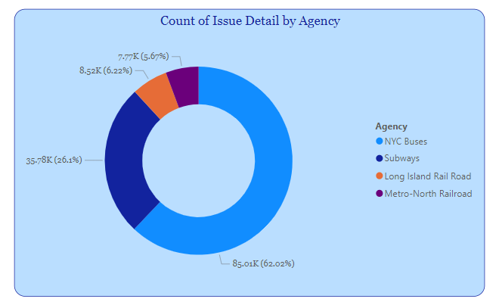

- Relation between commendation or complaint with Branch/ Line/ Route
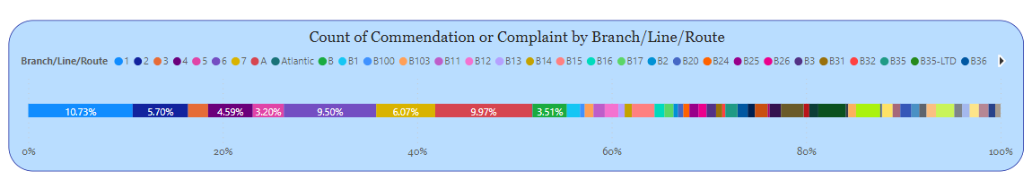

- Filter with Agency, Year, Subject detail, Subject Matter.

